Fish to Food Year 4 Food Technology |  |  |  |  | Curriculum Links: Geography: United Kingdom + Year 3 Science Animals including humans - Healthy Eating
DESIGNING |  | MAKING |  |  |  | EVALUATING |  | TECHNICAL KNOWLEDGE
Understanding contexts, users and purposes | When planning the mackerel pate snack, pupils will consider a variety of questions.  Who will be eating this snack? What is the purpose of the snack? Will I need to consider allergies or food intolerances?  What do we know about good nutrition? Has our learning in science helped us to understand this?  Is it important to think about how the snack looks? Does it need to be made appealing?  What ingredients are available? What ingredients are appropriate/ not appropriate? What is seasonable?  In exploring these questions, pupils will be able to generate a design specification. Is it realistic? | Planning  Practical Skills and techniques | What utensils/ equipment/ ingredients will you need?  What food products are or are not available? What is in season? How will this affect your design?  What has your learning in science told you about healthy foods? What are the needs and wants of your ‘client’?  What safety issues will you need to consider? Knife use, food management, hygiene and understanding of allergy.  Discuss, share and clarify ideas. Plan and record a step by step making process.  How will you present your made product?  Does your plan meet the demands of the design brief?  Select the right tools for the right tasks. Explain why it is the right tool.  Knife use.  Use an understanding of aesthetics for presentation of finished product. |  |  | Existing products | What will influence your design choices?  Explore existing recipes: Jamie Oliver, BBC Good Food etc. See IMAGE RESOURCES.  Seasonality, sustainability, health and nutrition.  Safety issues: allergy  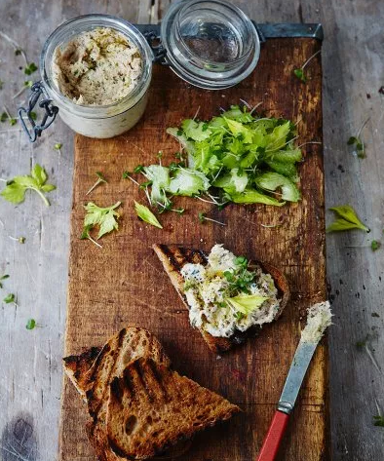  Have any other famous chefs/cooks designed recipes for a fish pate? What inspiration can you take from them? | Making products work | Food preparation skills and knowledge – knife safety and food hygiene  Using Science knowledge to inform designing for health.  Knowledge of how to use a range of techniques such as peeling, grating, chopping, slicing, mixing and spreading.  Know that a recipe can be adapted by adding or substituting one or more ingredients.  Knowledge that to be active and healthy, humans including animals, need food and drink to provide energy for the body.  Knowledge of sustainability – locally sourced products.
Generating, developing, modelling and communicating ideas | Provide pupils with ingredient options and limits. Possibilities: smoked or peppered mackerel, cream cheese, yoghurt, fromage frais, a variety of herbs for flavour, lemon, olive oil. Choices of garnishes or crudités: celery, carrot sticks, spring onion, lettuce leaves. Crackers, bread etc.  Pupils design their pate, selecting ingredients.  Create annotated diagrams of their designs; identify ingredients.  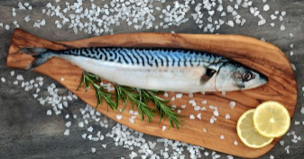  Where do the food products you are designing with come from? The UK, Europe or the wider world? Make links with the geography unit: the United Kingdom. |  |  |  |  | Key ideas and Individuals |  | Design and technology vocabulary |  | design brief  design specification  consumer  data  taste testing  food hygiene  appeal  annotated diagram  safety  visual appeal  research  product  variety  balance  energy  appearance  taste  texture  aroma  innovative  fresh ingredients  sustainability  aesthetics  presentation
 |  | VOCABULARY AND LANGUAGE | nutrition  seasonality  seasonal  safety  allergy  utensils  equipment  taste  savoury  recipe  adapt  substitute  peel  chop  slice  grate  spread | IMAGE RESOURCES for teachers  https://www.jamieoliver.com/recipes/fish-recipes/smoked-mackerel-pate-with-griddled-toast-and-cress-salad/  https://www.bbc.co.uk/food/recipes/smoked_mackerel_pt_with_36210  https://www.theguardian.com/lifeandstyle/wordofmouth/2012/may/24/how-perfect-smoked-mackerel-pate |  | Own ideas and products | Did your ‘client’ eat the snack?  Was the ingredient combination successful? Was it innovative?  Did you use the ‘consumer’ research to inform your design?  What was the opinion of your intended consumer?  Did your design meet the brief?  If you were to design again, what would you change, or keep the same?

